**Blockchain Basics Part-1**

**What is blockchain?**

Definition: Blockchain is a **shared digital ledger** in a public or private **peer to peer network**.

That’s a lot of heavy words. Let’s simplify it in a normal language.

**What is Digital ledger?**

Ledger is a book or computer file which used for recording a transaction. Typically, it tracks important details, date of transactions and amount transferred between participants.

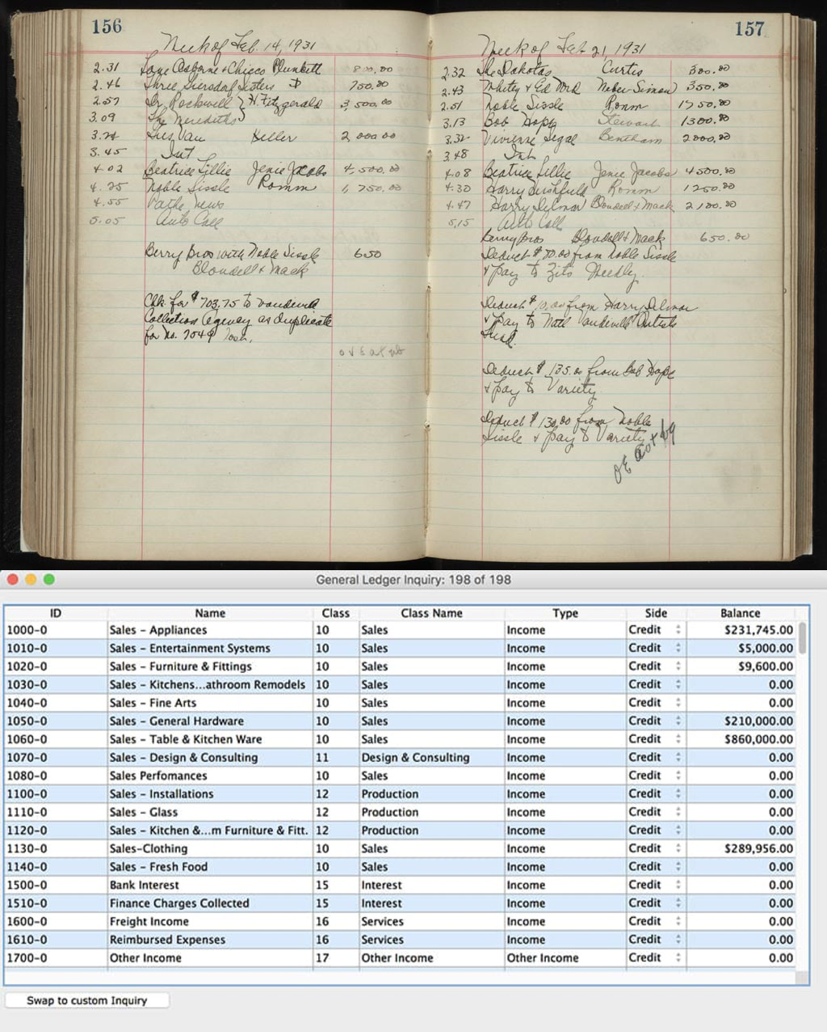

**What’s the problem with digital ledger?**

Think about any business where multiple stakeholders are having their own ledgers Which is very inefficient and subject to tampering.

Example: Person have a health insurance and person tries to claim an amount from insurance. There are different ledgers are used between stakeholders like patient, hospitals and insurance vender company.

* If insurance amount doesn’t add up to the same for all ledgers, it leads to disputes and more problems
* Maintenance time and cost for maintaining all ledgers is also very high
* Leads to a poor business decision
* Leads to a trust issue among parties doing business together
* Creates a duplicate entry to ledgers

**Solutions to above problems:**

What if there’s only one ledgers shared across all stakeholder which is distributed & replicate across all the participants in the network.

**What is distributed ledger?**

Distributed ledger is a type of database that is shared, replicated and synchronized in decentralized network.

Distributed ledger records the transactions, such as exchange of assets, etc. among the participants in network.

Participants in network govern and agree by consensus on the update to the records in the ledger.

**What is blockchain, exactly?**

**Blockchain is a type of database that is shared, replicated and synchronized among participants in network.**

Blockchain is a distributed digital ledger that records transactions in public or private peer to peer network.

It’s distributed to all member nodes in network

Ledger permanently records the transactions that’s why it is called immutable ledger

Each transaction creates a new block with the transaction values & cryptographic hash linked with its previous blocks

Sequential chain of transaction creates a chain of blocks in shared ledger that’s why it is called blockchain.

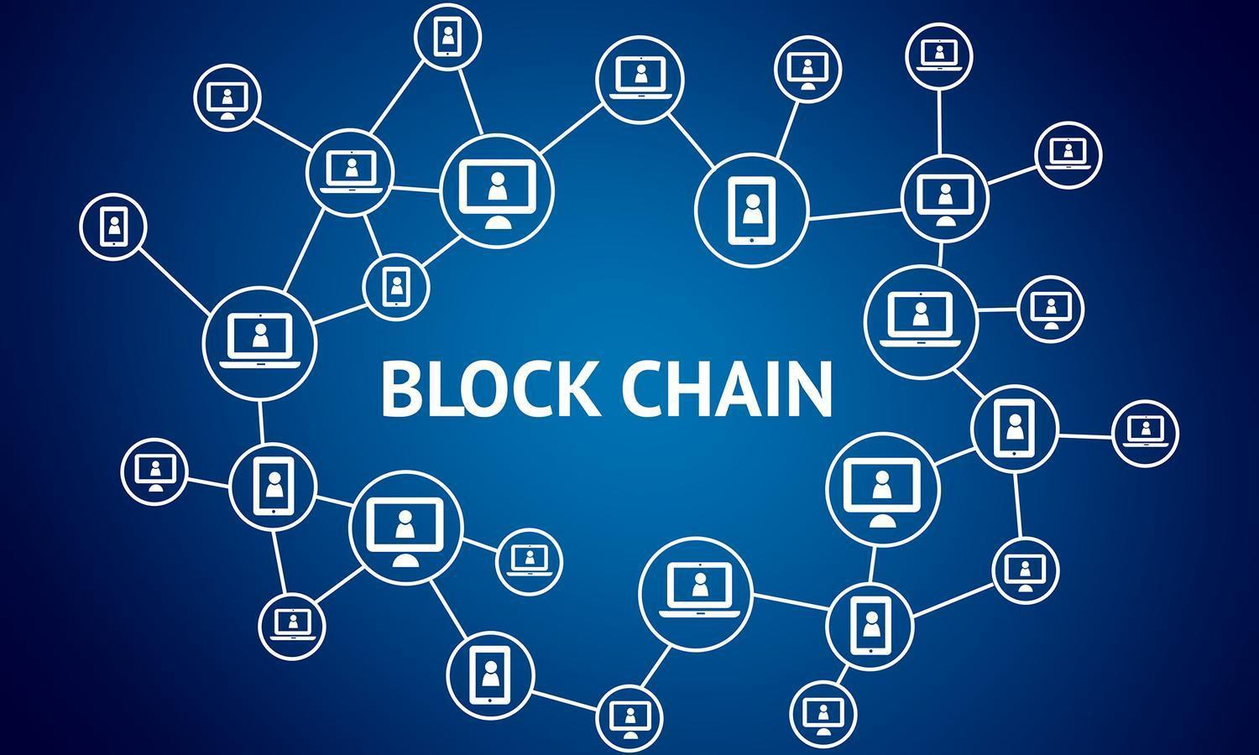

To know more about blockchain and how blockchain network work, stay tune for next post.

Till now happy reading!

For more info about blockchain: Check this Trailhead https://trailhead.salesforce.com/modules/blockchain-basics